Instructions for attaching a Mount’n Mover to a Motion Concepts Seat
There are several versions of the Motion Concepts seat frame, with multiple ways to attach.
Keep in mind, that these renderings do not display armrests, or thigh supports, which you may have to offset to accommodate.

Side-Mount Footrests: Type 1  See Instruction C or D | Side-Mount Footrests: Type 2  See Instruction C or D
Side-Mount Footrests: Type 3 (offset)  See Instruction C or D | Center-Mount Footrests: Round Tube Cross-Member  See Instruction B
Center-Mount Footrests: Square Tube Cross-Member  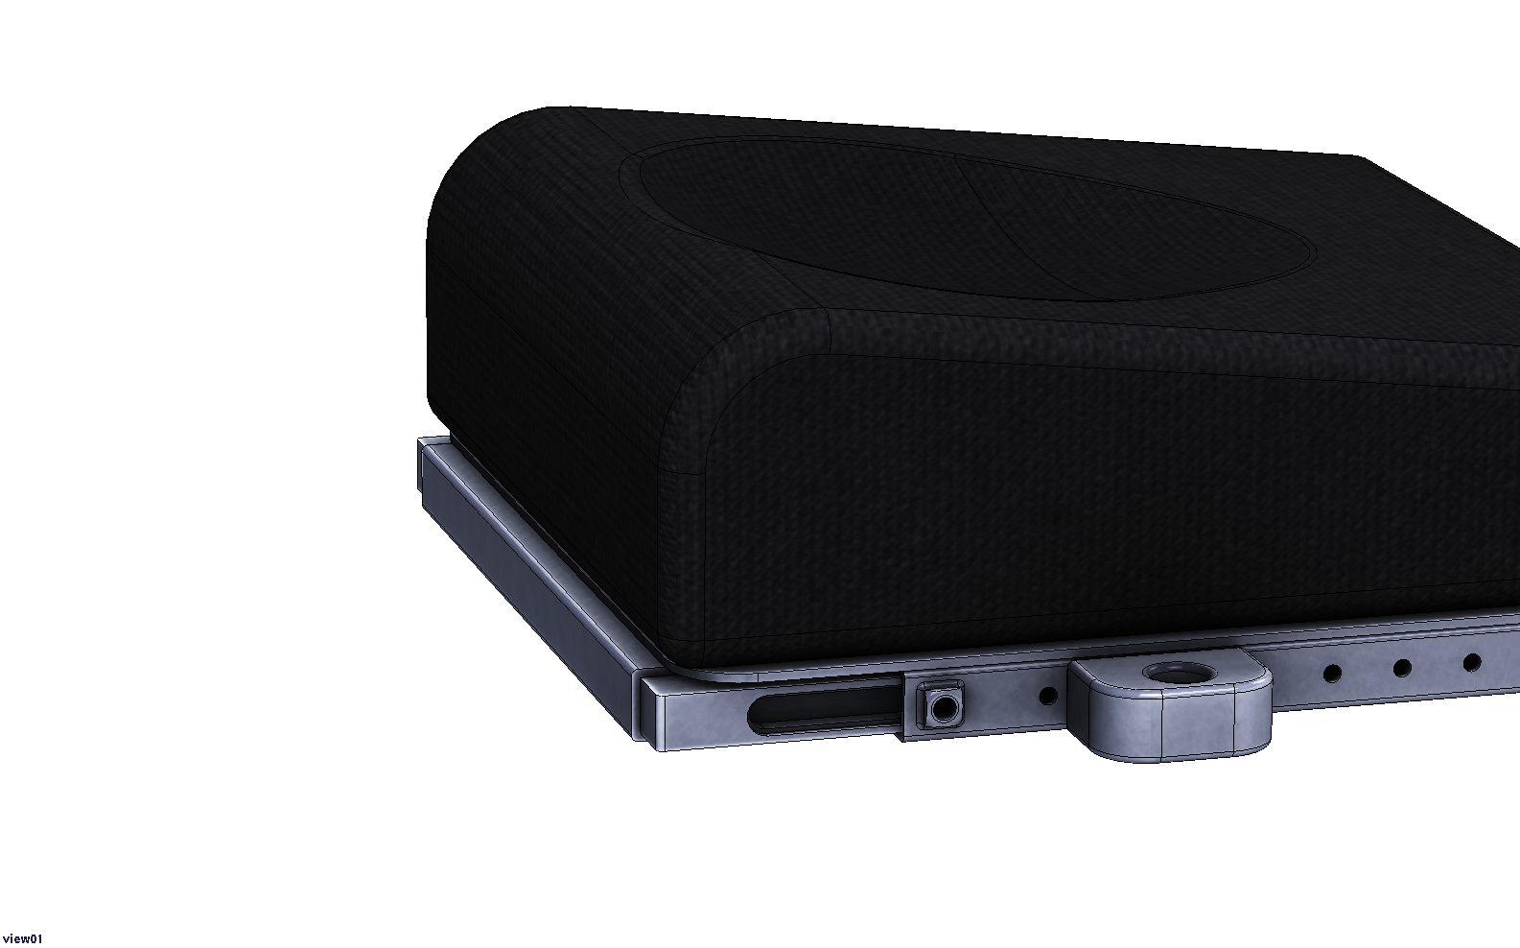  See Instruction B | Center-Mount Footrests: No exposed Channel  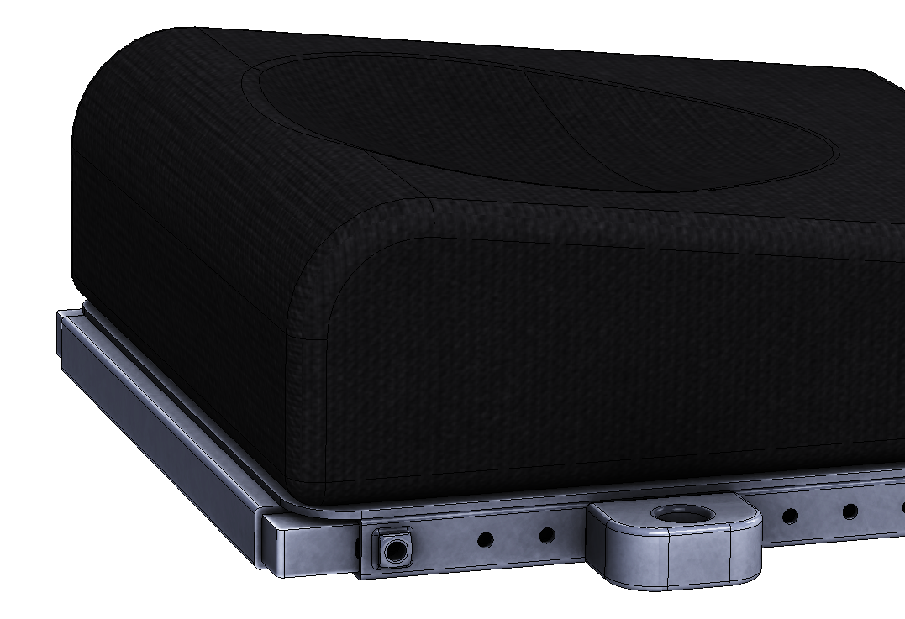  See Instruction A

Instruction A: Center mount footrest: No available holes on seat extension, and no access to “channel”
These instructions are for seats where: the seat depth is at it’s lowest setting, with little or no “channel” exposed on the seat rail.

- Pull out seat depth adjustment  First, record the current seat depth (to restore it when done)  Remove the 5/16” hex bolts that set the seat depth, and pull out seat to expose channel. | 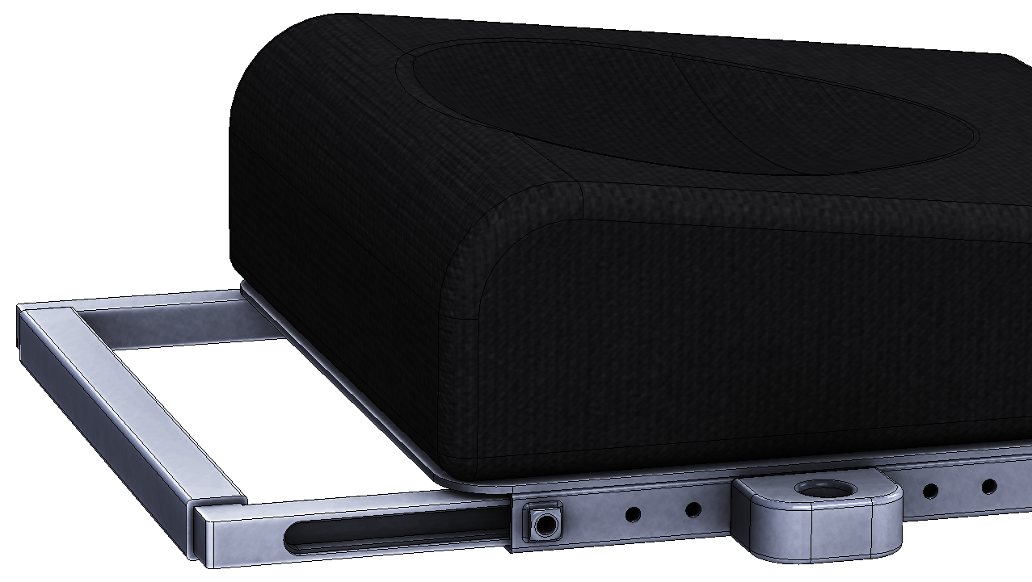
- Insert Nuts into channel  Insert the ¼-28 UNF nuts provided with the Mount’n Mover | 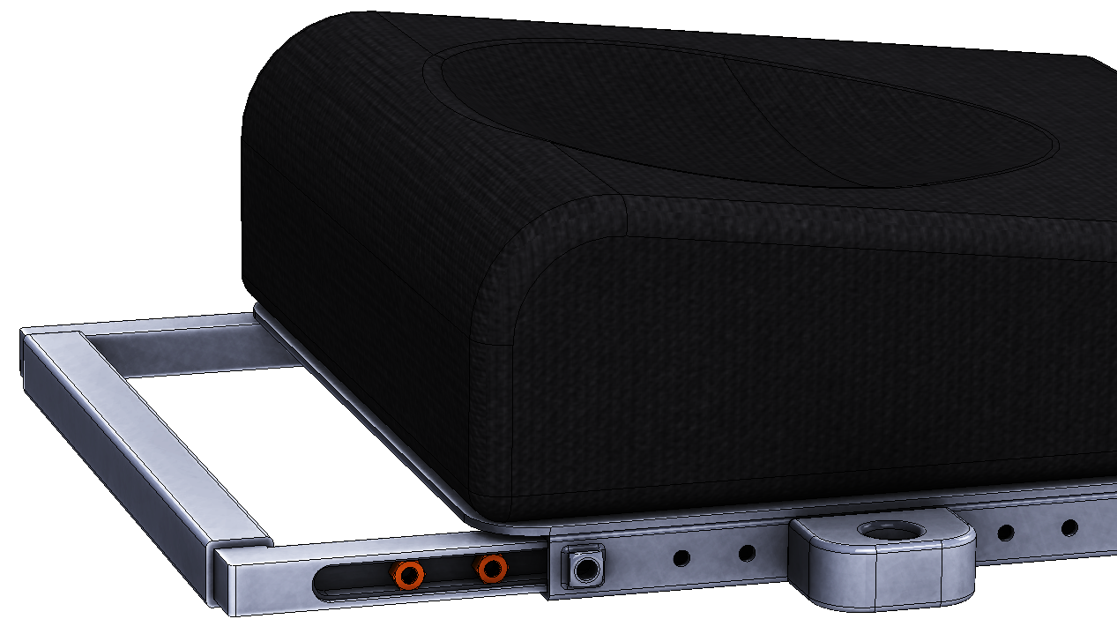
- Slide nuts into track to line up with holes.  (use the ¼-28 UNF bolts provided with the Mount’n Mover to thread nut and keep it in place) | 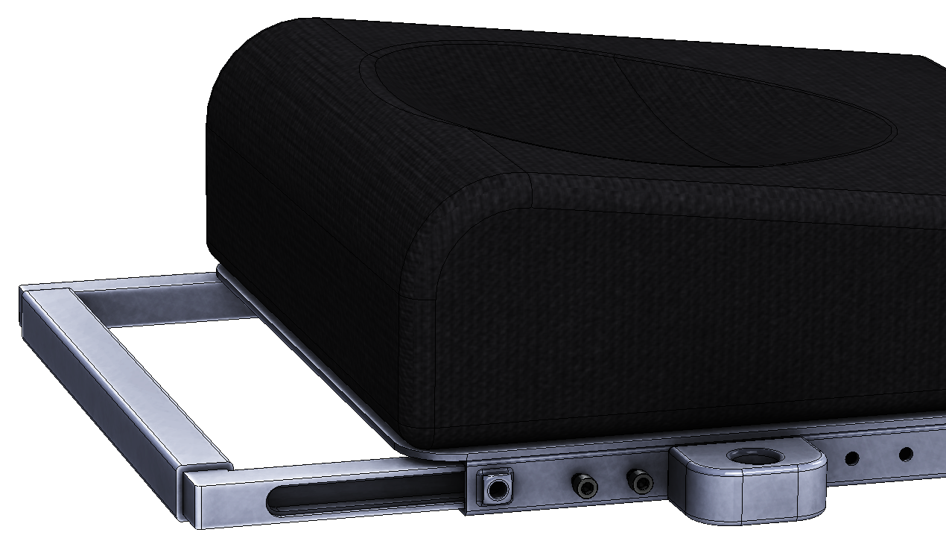
- Adjust seat depth back to original depth, keeping nuts in place (with use of bolts)
Re-insert the 5/16” hex bolts used to set the seat depth.
- Remove the bolts holding the nuts in place. Attach appropriate Adapter Plate (Adapter plate 4 shown), and re-use those same bolts to attach the plate to the nuts
Instruction B: Center mount footrest: When there is exposed “C-Channel” (at least 2”)
These instructions are for center mount footrest motion concepts seats, with at least 2” of the C-channel exposed.
- First, mark the seat depth distance on the seat rail. We will need to remove the seat depth adjustment, to insert the sleeve (pictured in orange).  Re-insert the seat depth piece with the sleeve included. | 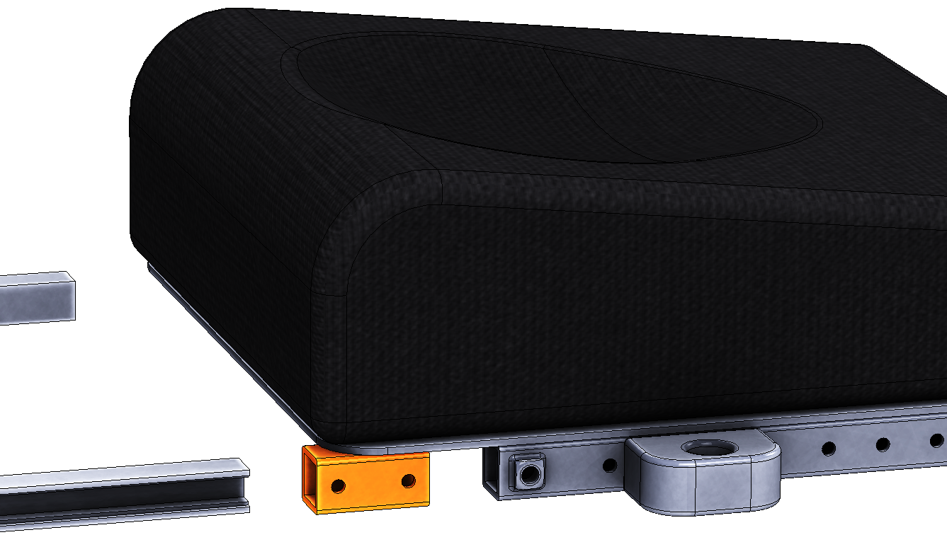
- Insert Nuts into channel  Insert the ¼-28 UNF nuts provided with the Mount’n Mover | 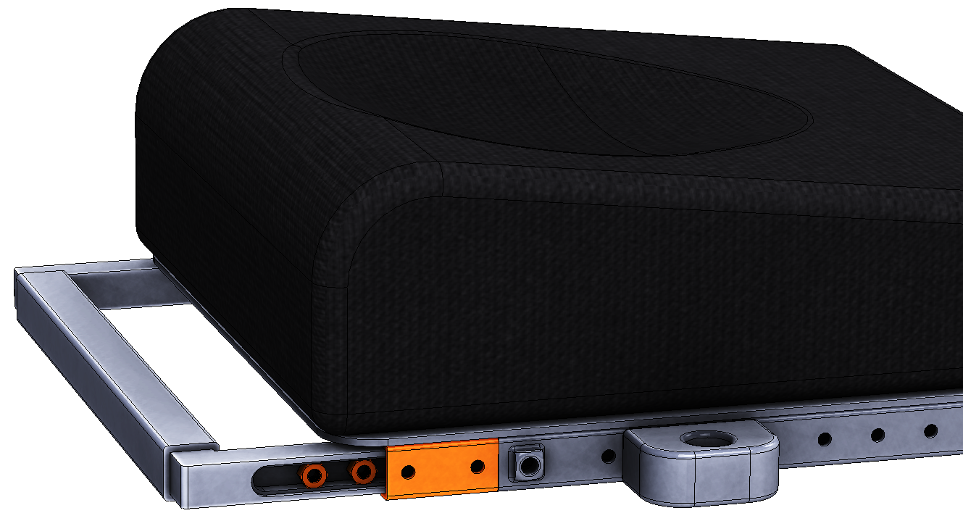
- Slide nuts into track to line up with holes.  (use the ¼-28 UNF bolts provided with the Mount’n Mover to thread nut and keep it in place) | 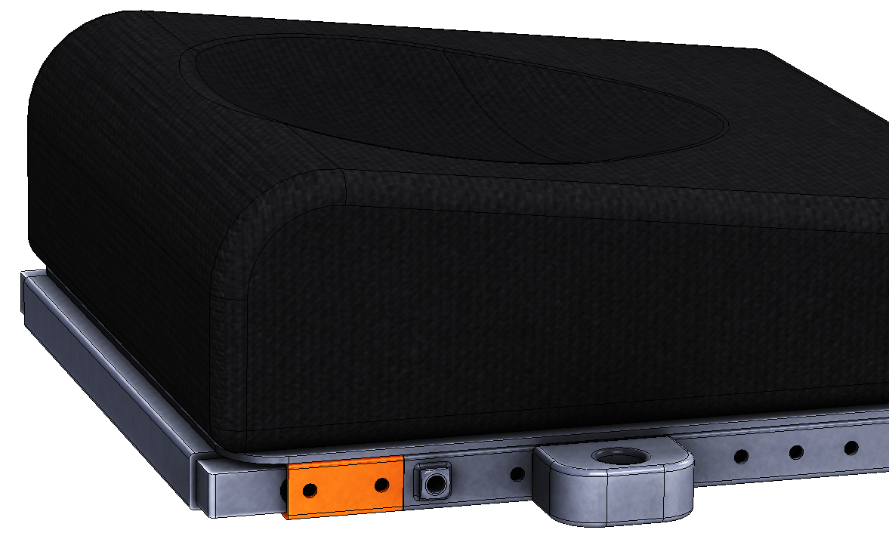
- Return the seat depth distance to the prescribed setting.  Re-insert the 5/16” hex bolts used to set the seat depth. | 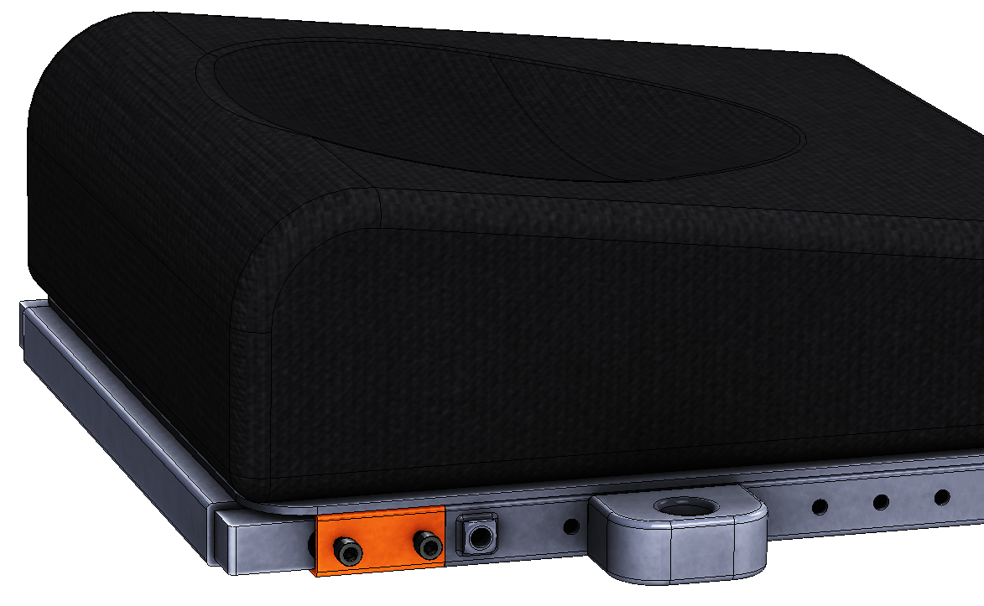
- Remove the bolts holding the nuts in place. Attach appropriate Adapter Plate (Adapter plate 4 shown), and re-use those same bolts to attach the plate to the nuts | 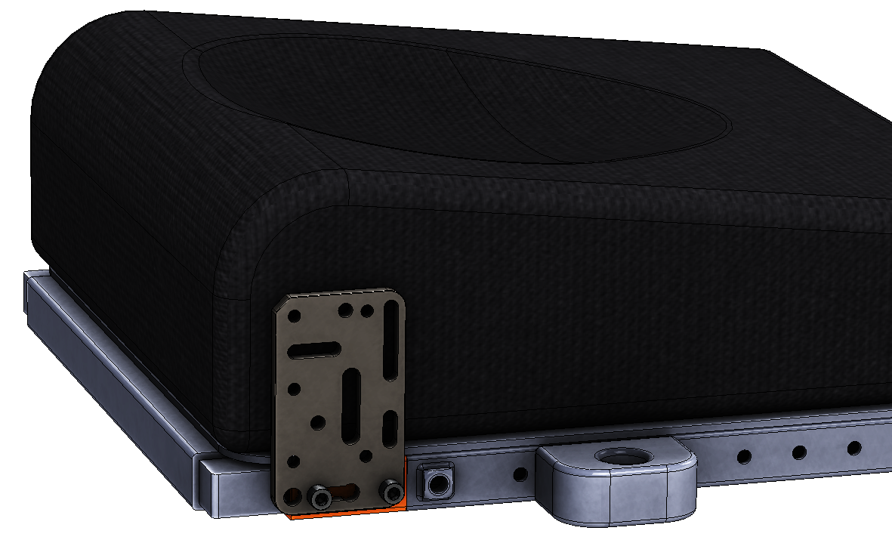
Instruction C: Side-mount footrests, with exposed holes on extension
These instructions are for side-mount footrest motion concepts seats, with exposed holes on the seat rail. (with at least 0.5” clearance on the rear side of the holes)
Preference is to bolt directly to the exposed holes. This method does not require moving the channel within the seat frame.
Picture Example (before mounting):  The two holes exposed towards the front of the seat rail provided for most expedient mounting. | 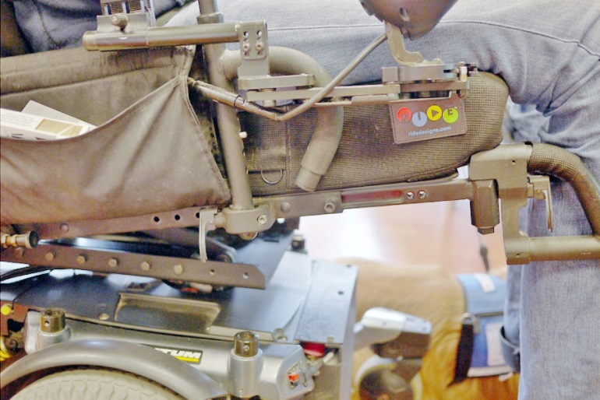
Picture Example (after mounting):  Adapter Plate (WC-AP) shown attached to the exposed holes.  Two L-Angle Extensions (WC-LAE) are used to offset around the joystick.  Solid wheelchair bracket (WB2) is attached. | 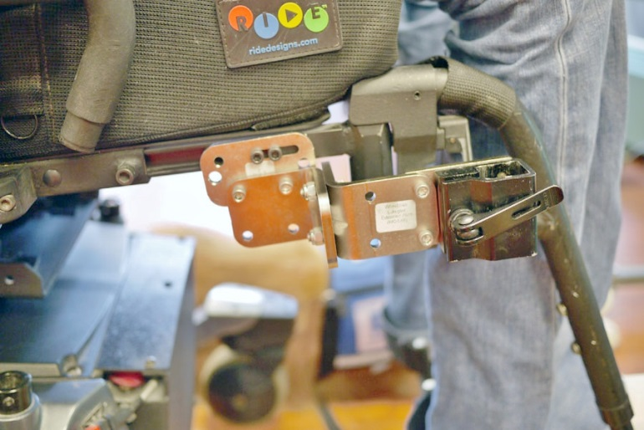

Instruction D: Side mount footrests, channel attachment (requires at least a 2” of available channel)
These instructions are for side-mount footrest motion concepts seats. The first choice of mounting is to use available holes in the seat frame. If not available, it is possible to mount to the channel (requires at least 2” of space along channel). | 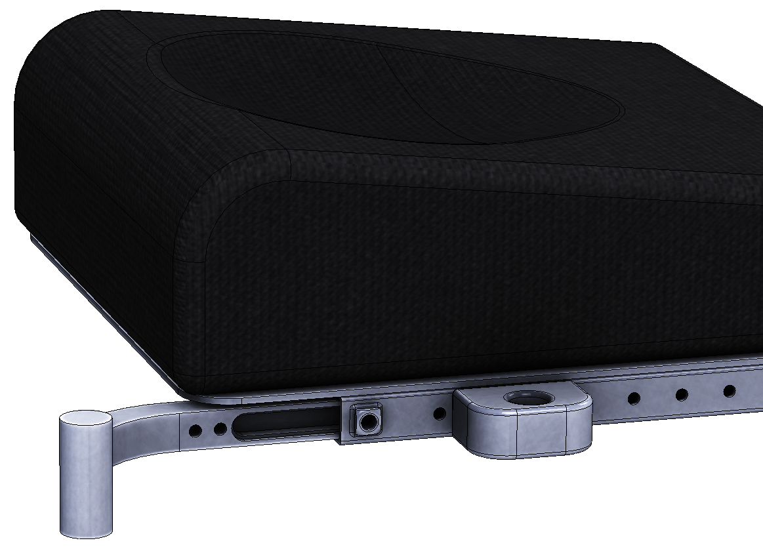
- First, mark the seat depth distance on the seat rail. We will need to remove the seat depth adjustment, to insert the sleeve (pictured in orange).  Re-insert the seat depth piece with the sleeve included. | 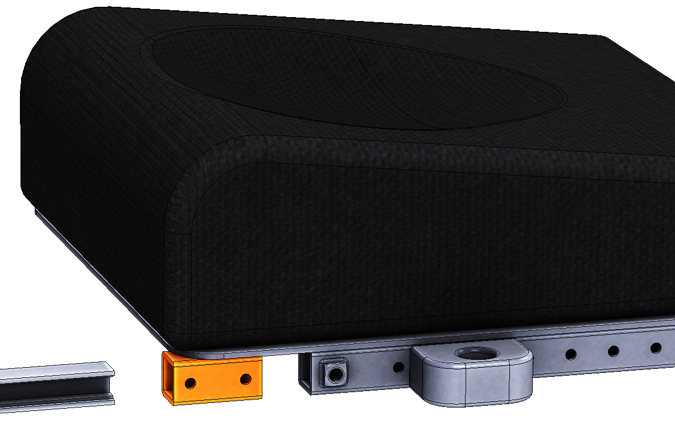
- Insert Nuts into channel  Insert the ¼-28 UNF nuts provided with the Mount’n Mover | 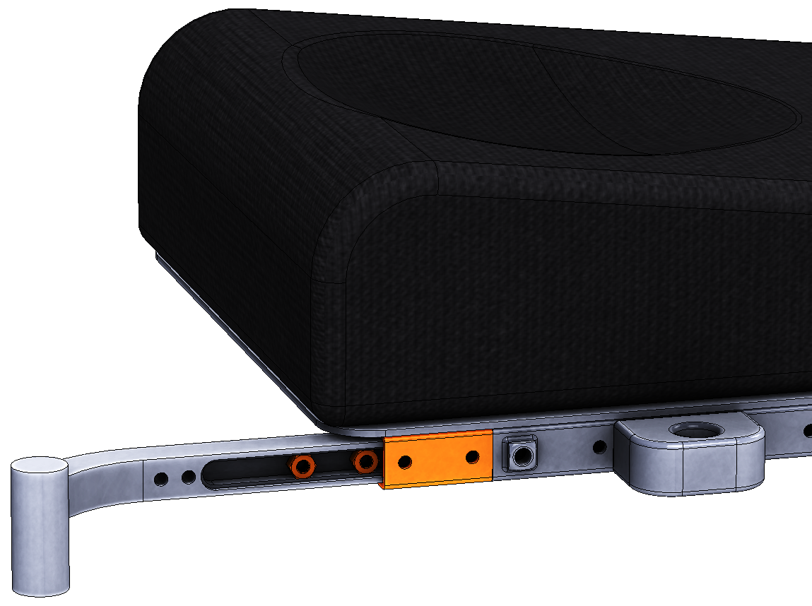
- Slide nuts into track to line up with holes.  (use the ¼-28 UNF bolts provided with the Mount’n Mover to thread nut and keep it in place) | 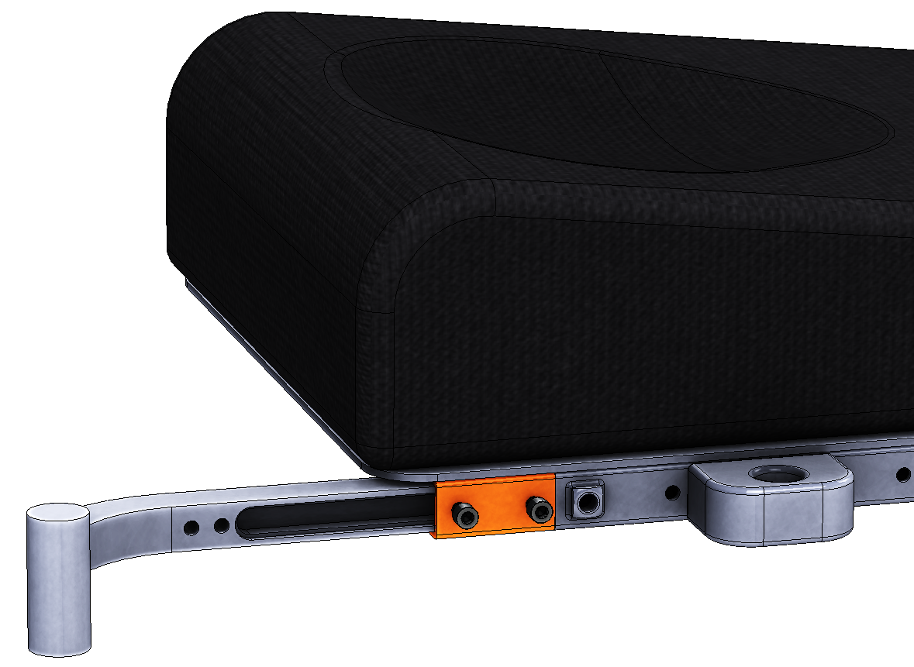
- Return the seat depth distance to the prescribed setting.  Re-insert the 5/16” hex bolts used to set the seat depth. | 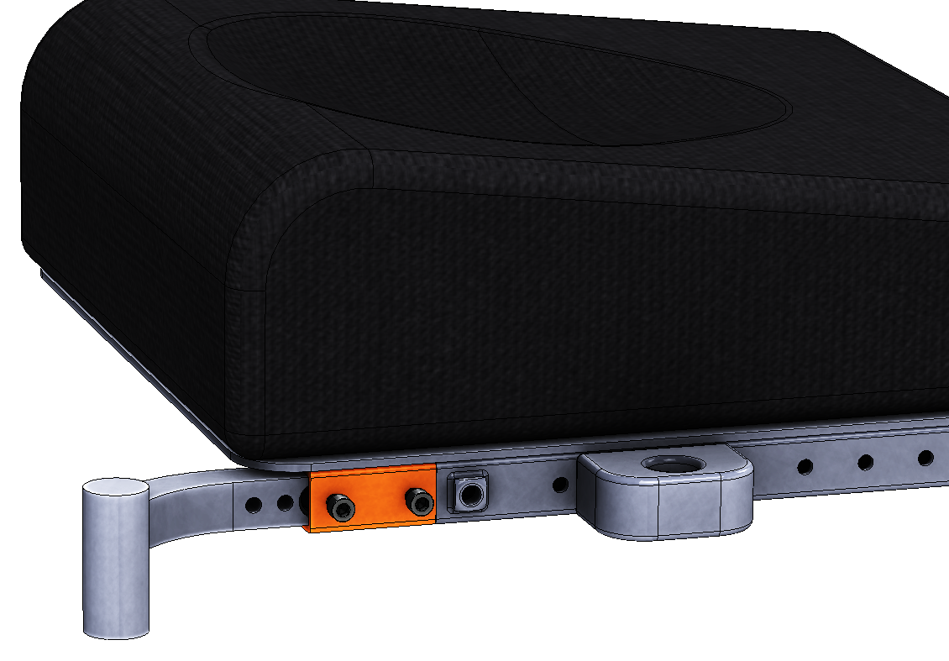
- Remove the bolts holding the nuts in place. Attach appropriate Adapter Plate (Adapter plate 4 shown), and re-use those same bolts to attach the plate to the nuts | 